CS4200 Final Project – United States Gas Prices from Jan 2026 – Mar 2026

Overview
This project was for my Big Data Analysis class. In this project I explore and analyze a data set on gas and oil prices since before the Iran US conflict in 2026 until end of march 2026.

The Data Set
The data set that was used for this project was the Iran War Oil Shock 2026 | Brent & Gas Tracker. This data set was found on kaggle with a gold rating and 10.0 usability. The GetDataSet.py file in my project is a script to grab the data set from kaggle and place it into the users working directory.
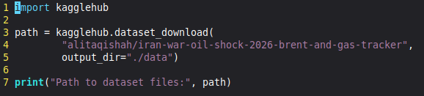

Data Exploration
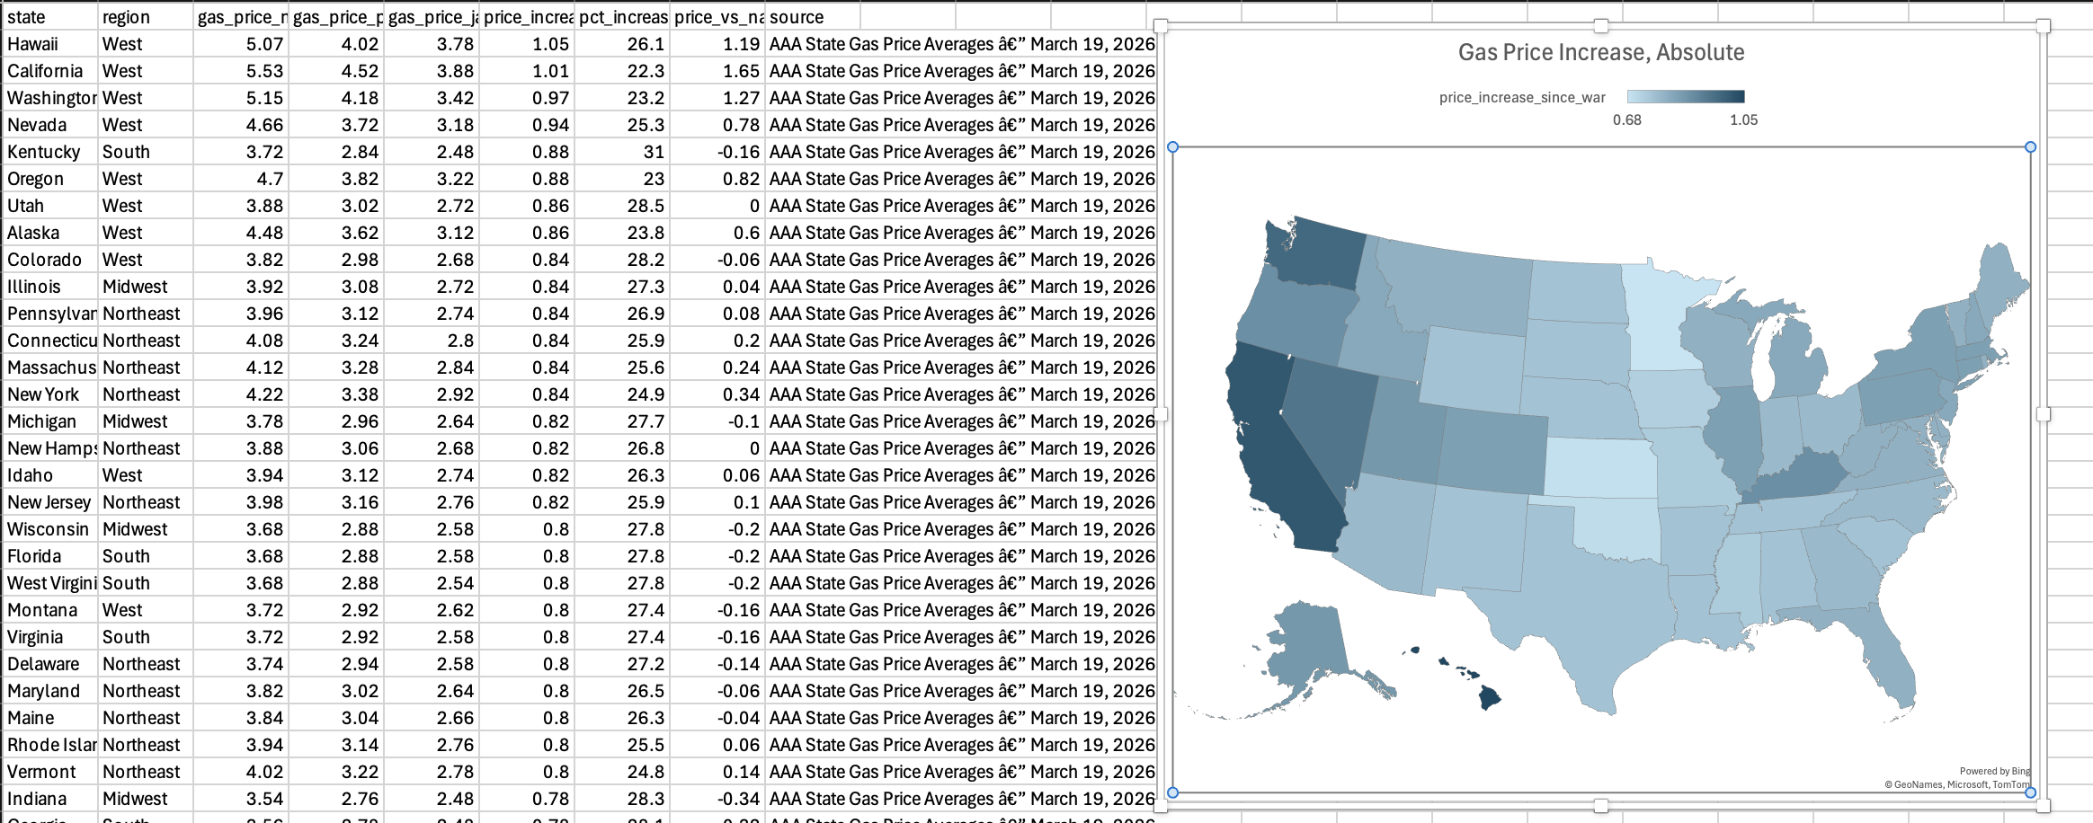
The data set is split into three different CSV files iran_war_gas_prices_by_state.csv, iran_war_key_events_timeline.csv, and iran_war_oil_prices_daily_2026.csv. In this project I explored the iran_war_gas_prices_by_state.csv and iran_war_oil_prices_daily_2026.csv in excel. At first I was interested in evaluating the different US. states and how they were effected by the change in gas prices. To show some of the effects I sorted and filtered the data and created some visualizations. The first visualization is the states absolute price increase from Jan 8 to Mar 19.
As you can see from this graph the range of absolute increase goes from light to dark, meaning the lighter colored states had less of an absolute increase while the darker colored states had more of an absolute increase. This second graph shows the percentage increase from light to dark.
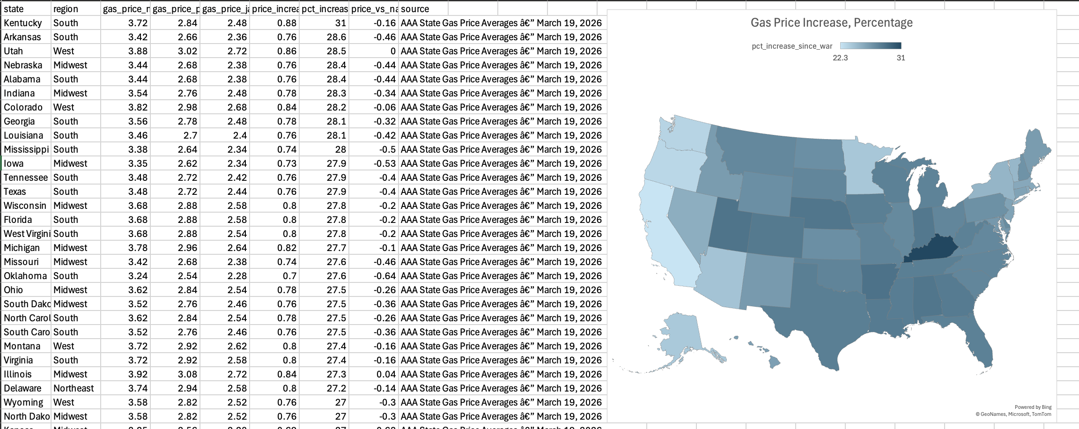
From these two graphs we can see that while the absolute increase affected most heavily the western states, the percentage increase affected the Midwest / southern states the most.
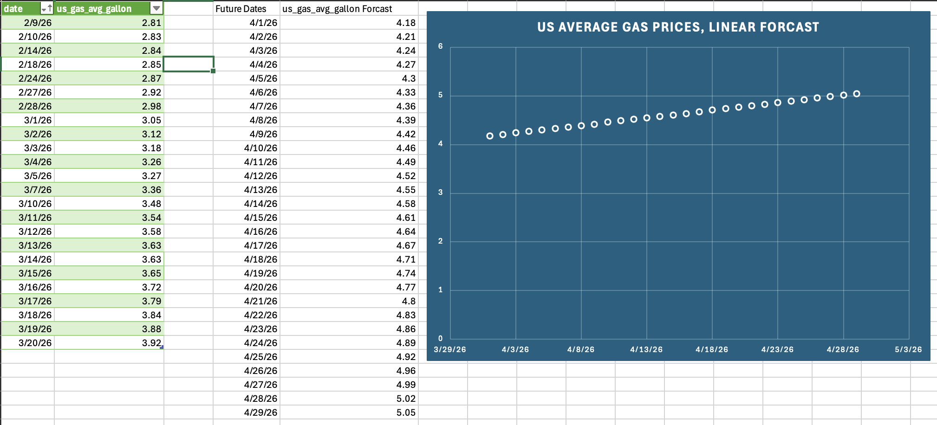
After a few more graphs and sorts I noticed in the iran_war_oil_prices_daily_2026.csv that the data set had a US. Average gas price column. Noticing this I was excited to do some predictive analysis on this data set and in excel charted out a linear forecast to see what the gas prices could have potentially been in early April. It was not accurate.

Data Wrangling
I decided that I wanted to do some more predictive analysis on the Average US gas price and see what values effected it and what not. Before doing any analysis I decided it would be good to cleanse the data. To preform some of this data wrangling I used python with pandas and sklearns DBSCAN, Oh and also the book.
In python I imported the csv checked the first few rows, checked if any files were duplicate, and checked if any values were null. Lastly I created a DBSCAN to check for any outliers on the gas price. Below I have the output.
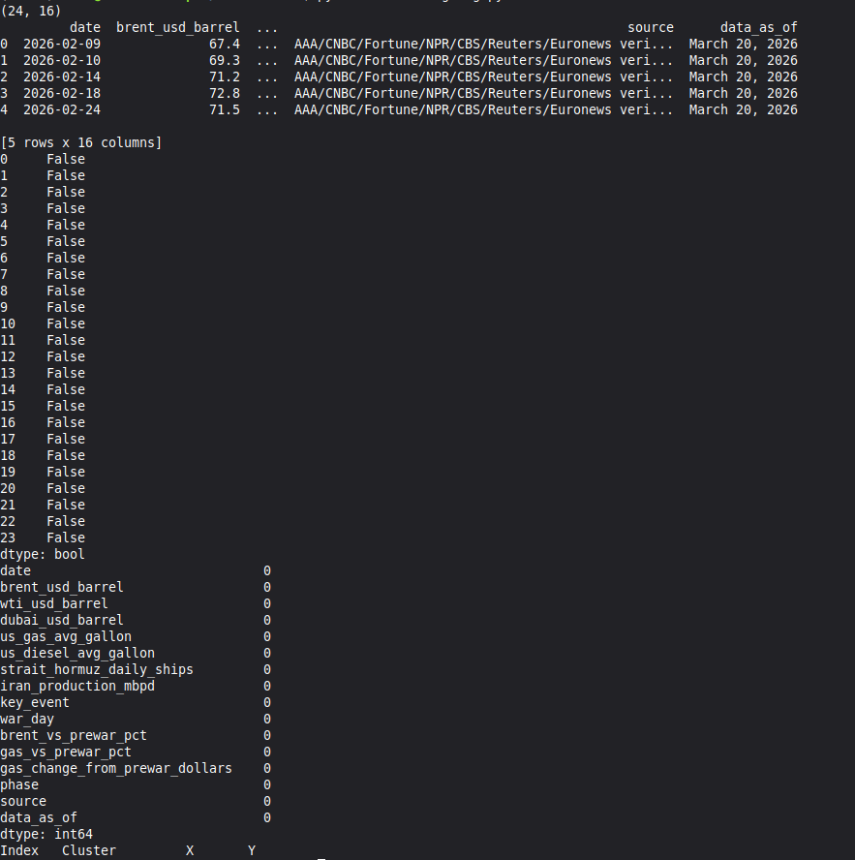
As you can see from this output the data was pretty clean.

Predictive analysis
So after cleansing and exploring the data I was really excited to see how the different variables that were given in the data set could effect the average US. Gas price. I live in the United States and so understanding how these variables effected our gas prices was very interesting. To preform this predictive analysis I used the Random Forest Regressor from sklearn, numpy, pandas, and python. The variables that were assigned to the x value were brent_usd_barrel, wti_usd_barrel, dubai_usd_barrel, strait_hormuz_daily_ships, iran_production_mbpd, war_day, brent_vs_prewar_pct, gas_vs_prewar_pct, and gas_change_from_prewar_dollars. The Y value was assigned to ‘us_gas_avg_gallon. Below is the output from running the prediction.
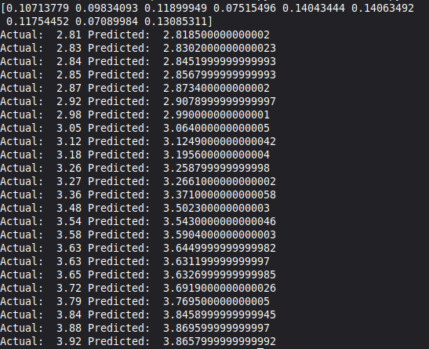
From this output we can see that with all the other factors that I included the model was pretty accurately predicting what the average gas price was going to be in the US.

Conclusion.
In the future I would like to dig deeper into the predictive analysis aspect of this project. I would run some other test to find out which variables were most likely to predict the gas prices and with that information make some more predictive models for the data set. There is also a key events csv in this data set that deals with key events from the war. In the future I would like to incorporate this knowledge to help with the predictions to see what sort of events had the greatest effect on the gas prices. But for what I have done with this project with the knowledge I have I feel satisfied with the outcomes.

